Problem Statement | predictive  model which will predict the Chronic Kidney Disease (CKD) based on the  several parameters
Step 1 | Number - Machine Language
Step 2 | Outout is very clear - Supervised
Step 3 | Output is not number - Classification

Input | sg | a,b,c,d | Ordinal
 | rbc | normal,abnormal | Nominal
 | pc | normal,abnormal | Nominal
 | pcc | present,notpresent | Nominal
 | ba | present,notpresent | Nominal
 | ht | no,yes | Nominal
 | dm | no,yes | Nominal
 | cad | no,yes | Nominal
 | appet | yes,poor | Nominal
 | pe | yes,poor | Nominal
 | ane | no,yes | Nominal
Output | classification | no,yes

Nominal | One Hot Encoding
Ordinal | Mapping Label Encoder

Classification | f1-score | roc-auc-score
1.SVM | 0.739582465 | 0.883259259
2.DT | 0.98340188 | 0.986666667
3.RF | 0.991647444 | 1
4.Logistic Regression | 0.97505347 | 0.998518519
5.KNN | 0.786363636 | 0.864592593
6.1. NaiveBayes-GaussianNB | 0.975148124 | 1
6.2. NaiveBayes-MultinomialNB | 0.901428571 | 0.952592593
6.3. NaiveBayes-BernoulliNB | 0.975148124 | 0.996740741
6.4. NaiveBayes-CategoricalNB | Error
6.5 NaiveBayes-ComplementNB | 0.893279436 | 0.952592593

Best Model is RF

- SVM 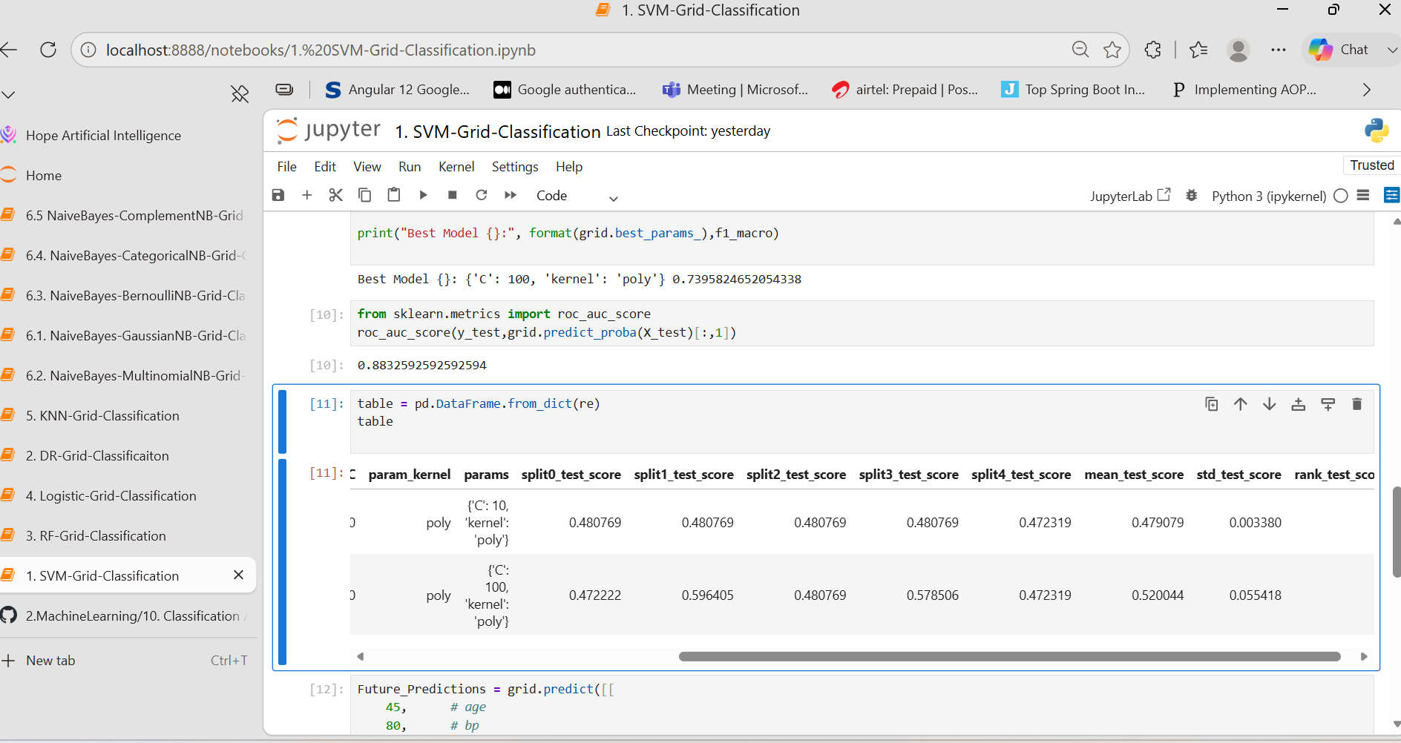
- DT 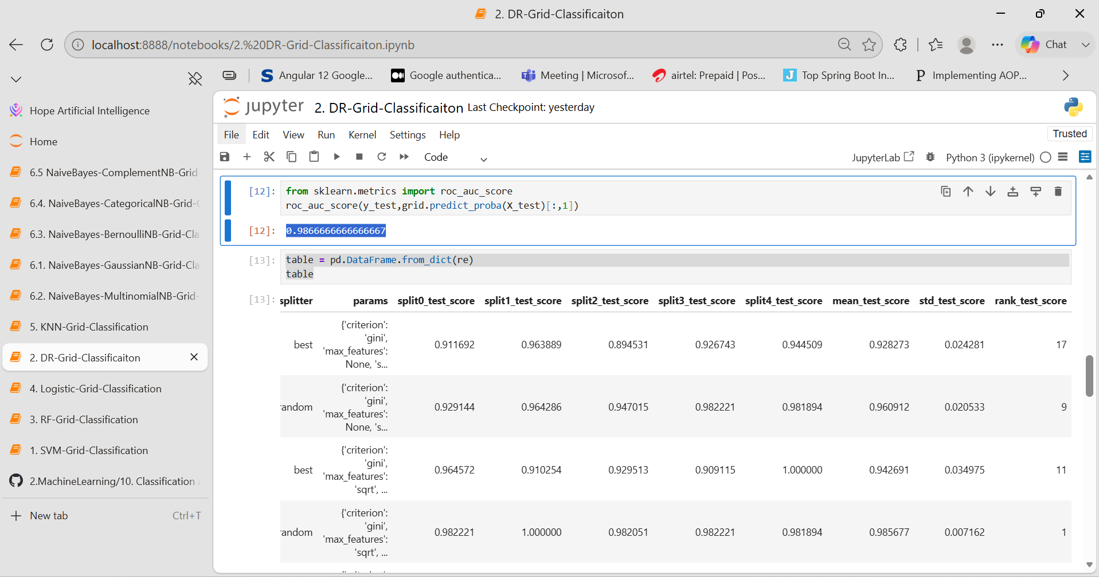
- RF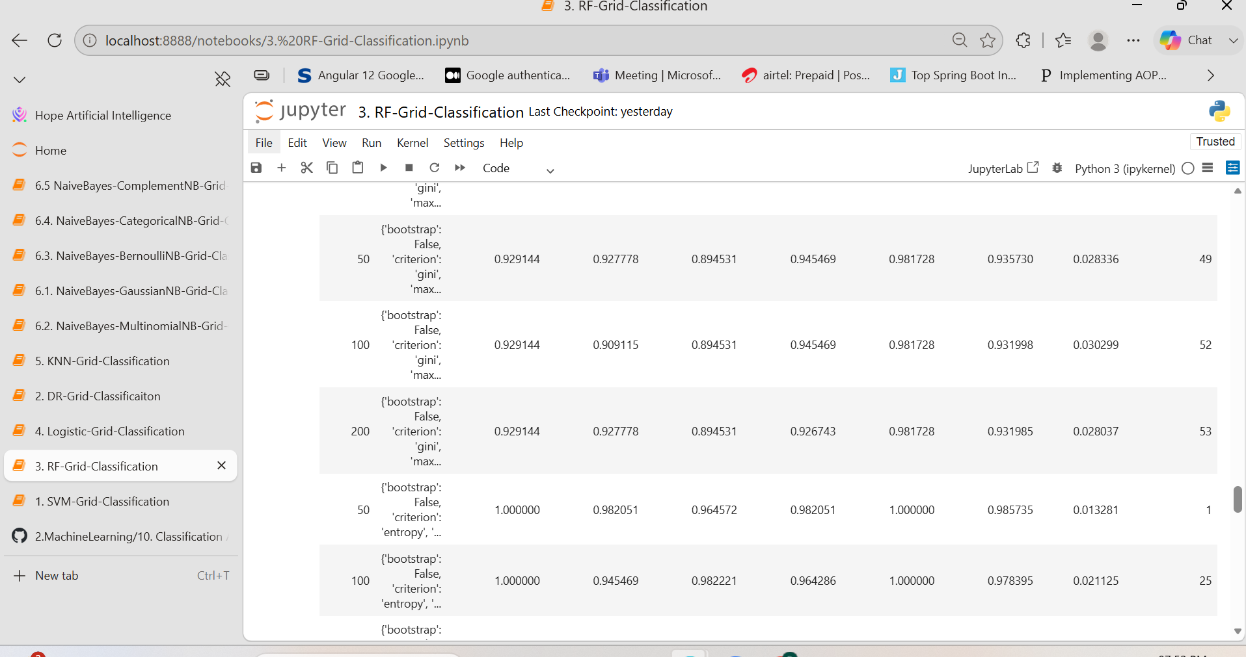
- Logistic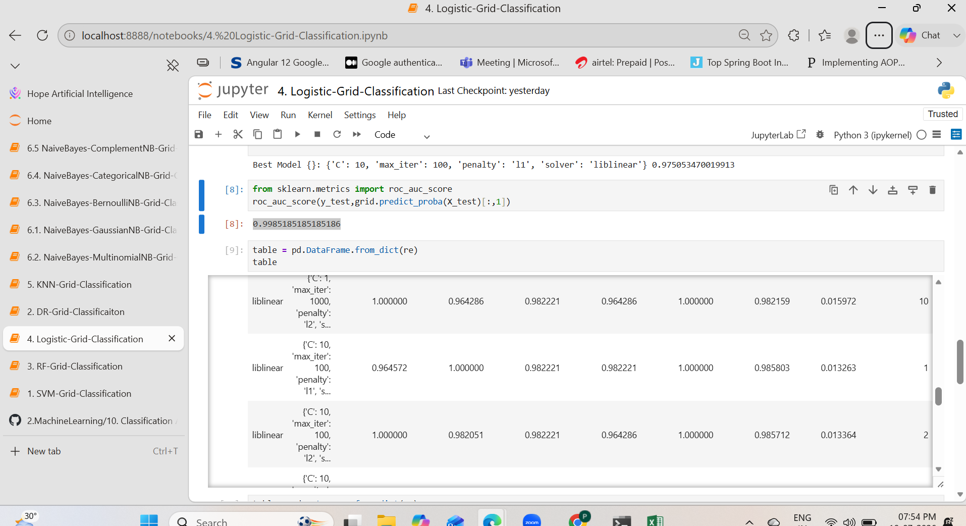
- KNN
- NavieBayes
NaiveBayes-GaussianNB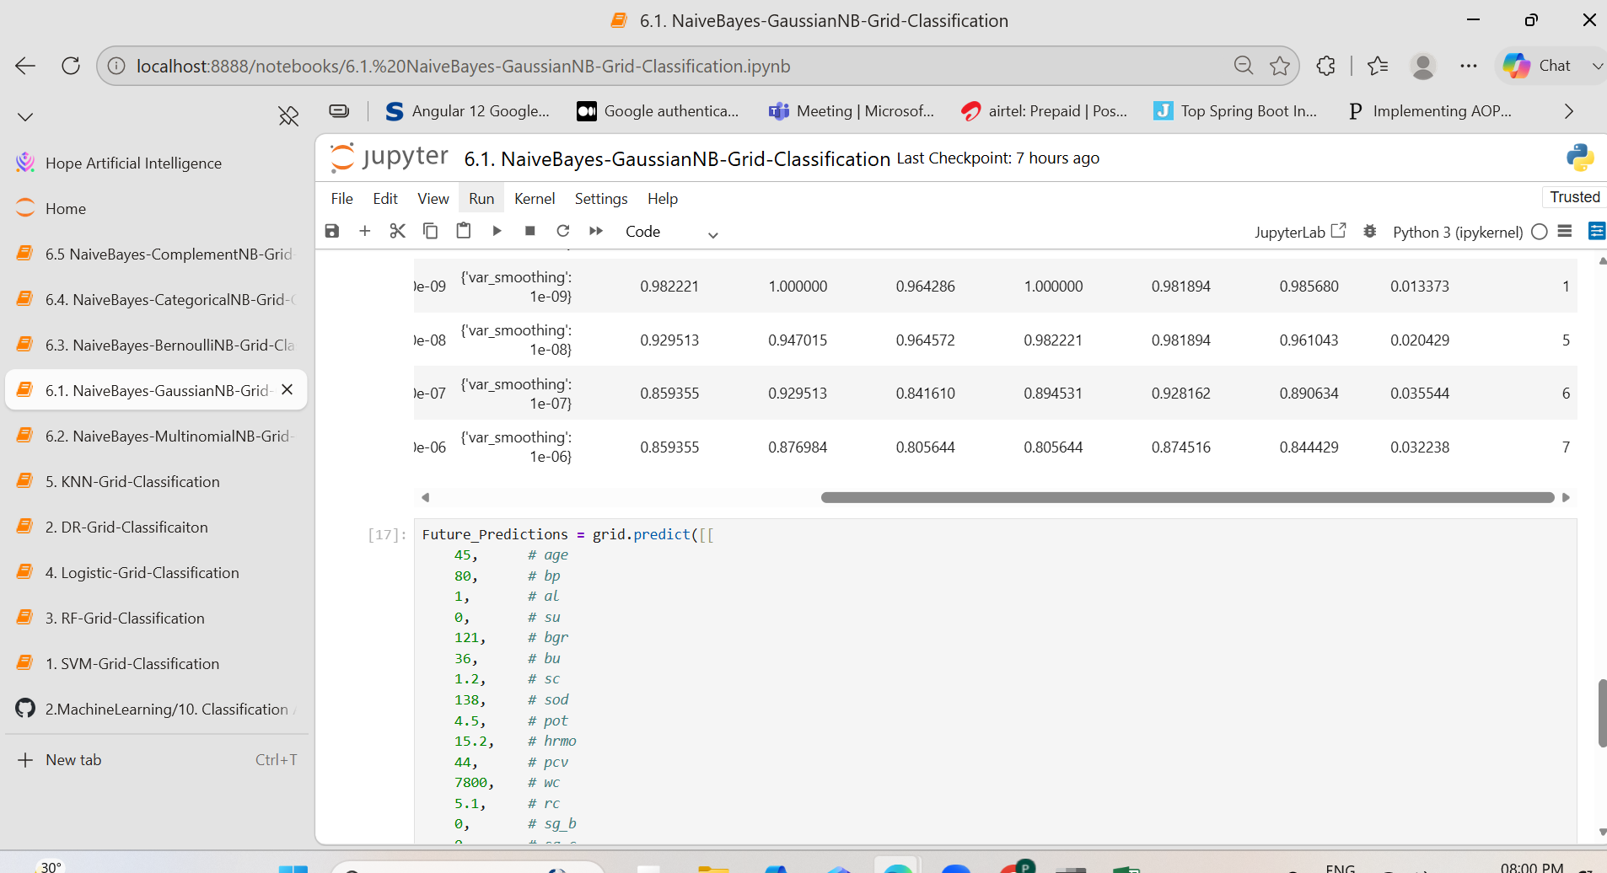
NaiveBayes-MultinomialNB
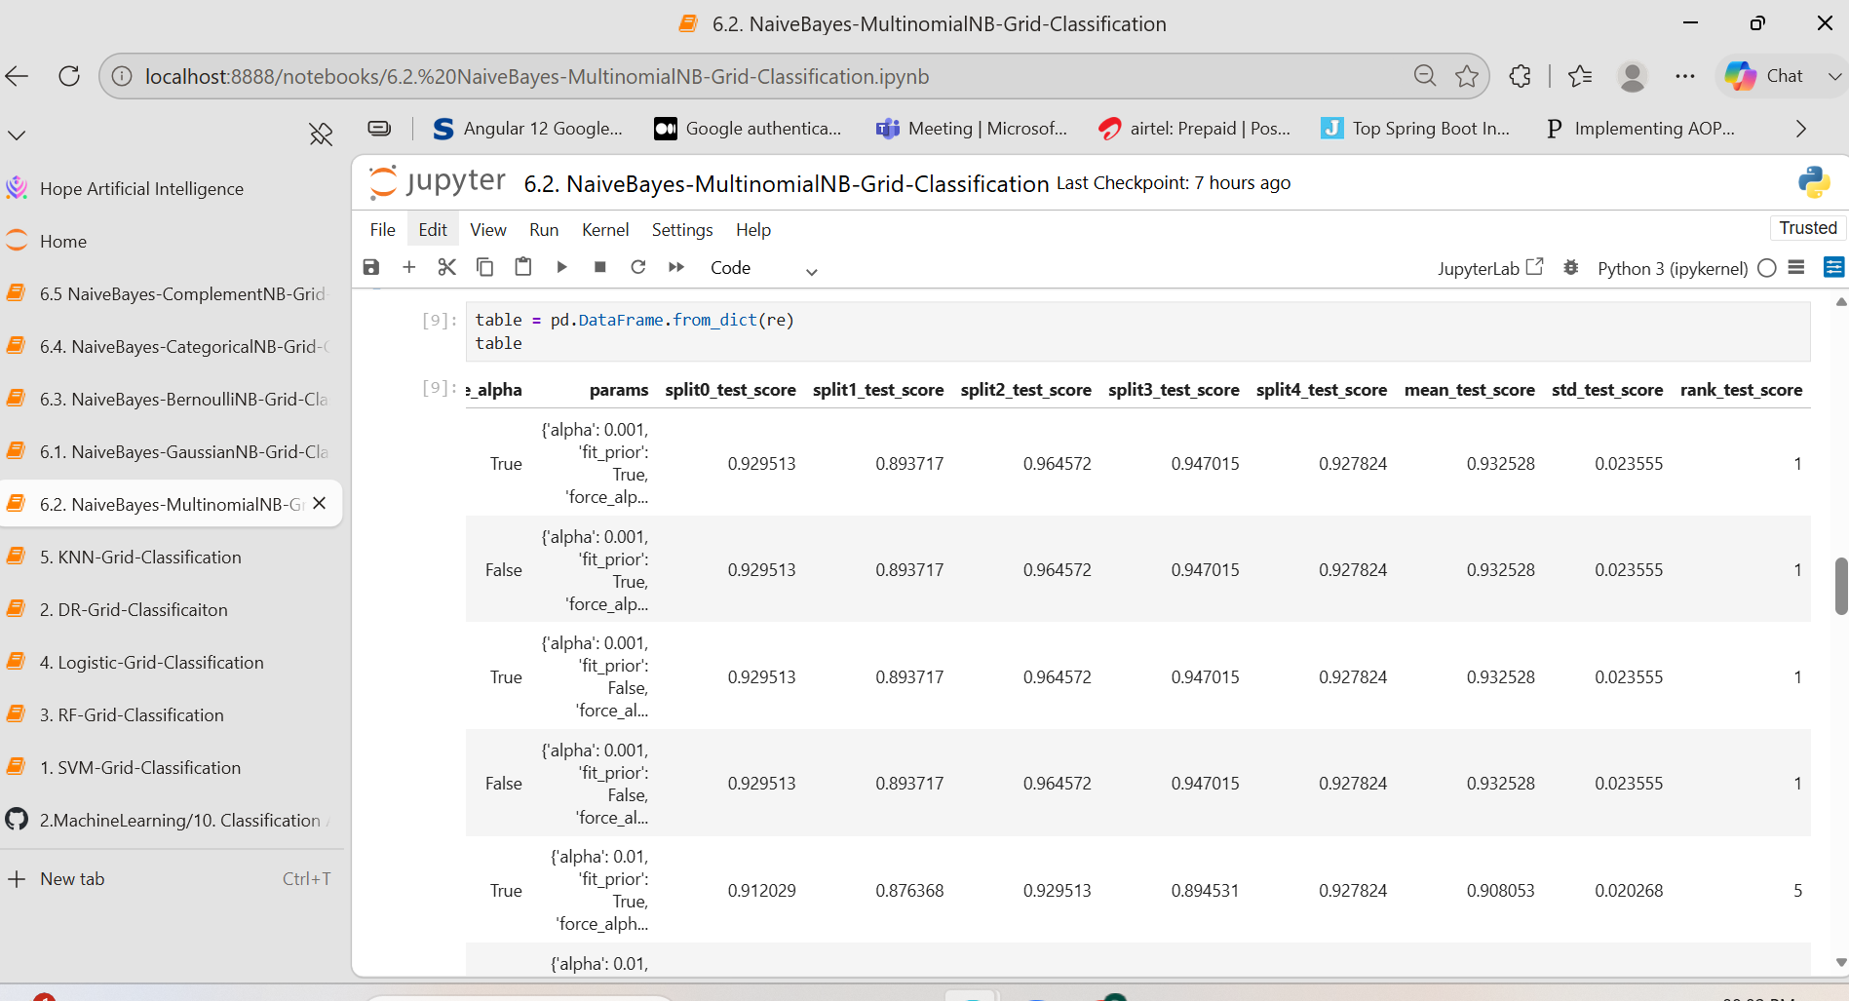
NaiveBayes-BernoulliNB
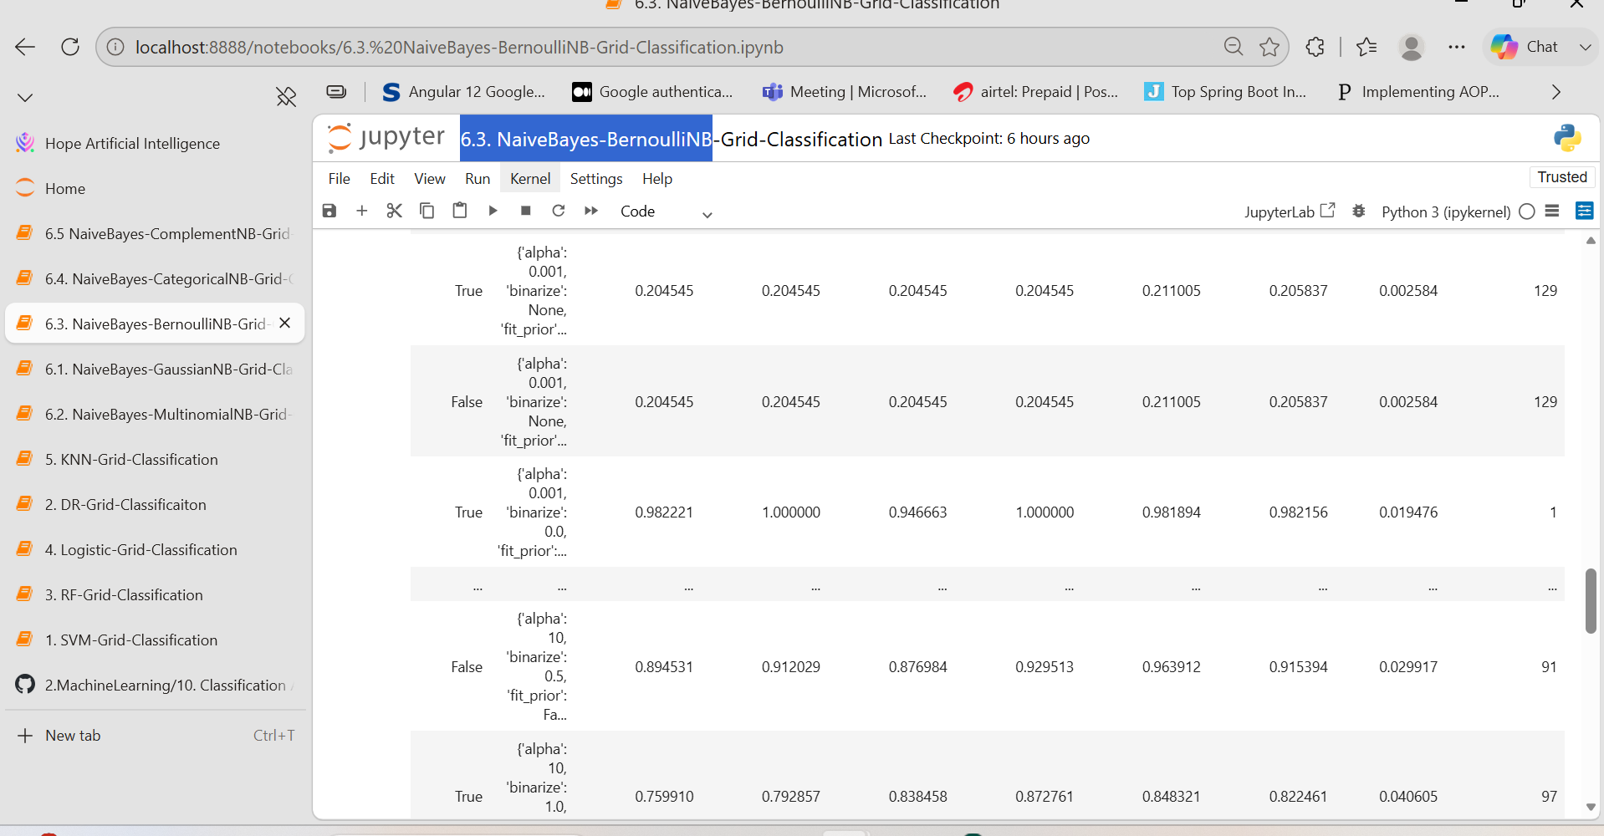
NaiveBayes-CategoricalNB
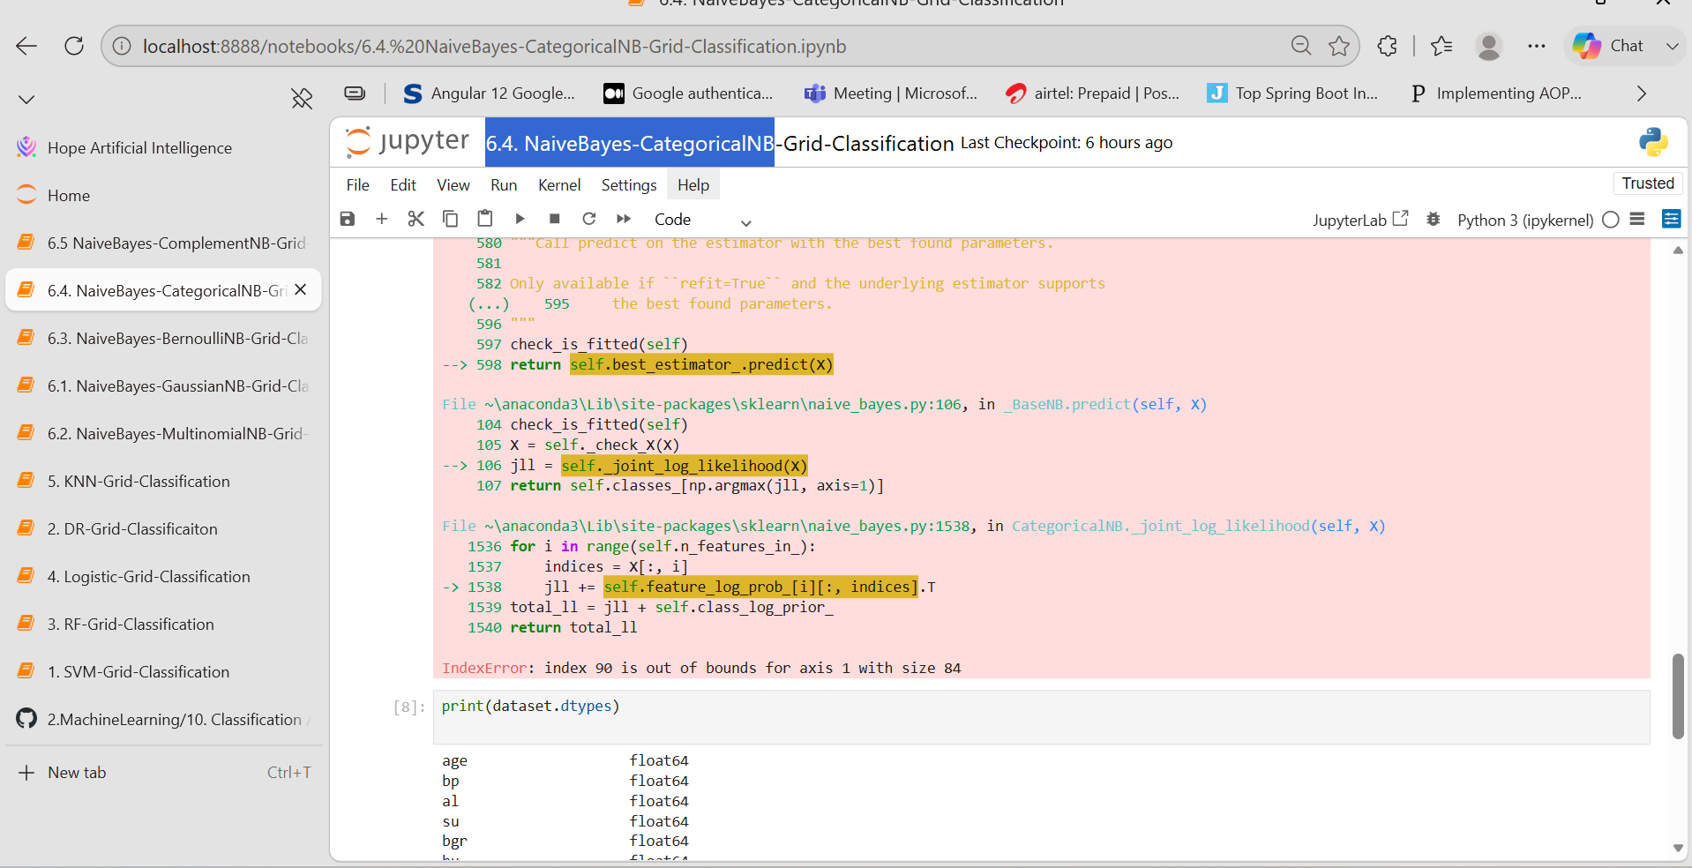
NaiveBayes-ComplementNB
